**Semantic Tags**

Semantics is the study of the meanings of words and phrases in a language.

Semantic elements = elements with a meaning.

## 

## **What are Semantic Elements?**

A semantic element clearly describes its meaning to both the browser and the developer.

Examples of **non-semantic** elements: <div> and <span> - Tells nothing about its content.

Examples of **semantic** elements: <form>, <table>, and <article> - Clearly defines its content.

Semantic tags in HTML5 Are As follows

* <article>
* <aside>
* <details>
* <figcaption>
* <figure>
* <footer>
* <header>
* <main>
* <mark>
* <nav>
* <section>
* <summary>
* <time>

**1.Section Tag**

The <section> tag defines sections in a document, such as chapters, headers, footers, or any other sections of the document.

**Example:**

<!DOCTYPE html>

<html>

<body>

<section>

<h1>Intro to Section Tag</h1>

<p>The "<section>" tag defines sections in a document, such as chapters, headers, footers, or any other sections of the document.</p>

</section>

</body>

</html>

**Output:**

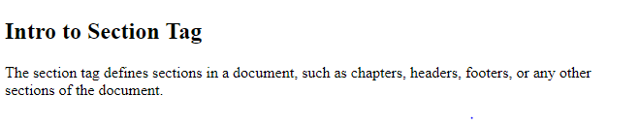

**2. The article Tag**

The <article> tag specifies independent, self-contained content.

An article should make sense on its own and it should be possible to distribute it independently from the rest of the site.

Potential sources for the <article> element:

* Forum post
* Blog post
* News story
* Comment

**Example:**

**<article>**

**<h1>Google Chrome</h1>**

**<p>Google Chrome is a free, open-source web browser developed by Google, released in 2008.</p>**

**</article>**

**Output:**

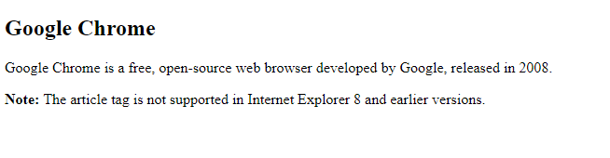

**3. Outlining**

An outline is a line that is drawn around elements, OUTSIDE the borders, to make the element "stand out".

**3.1 How Outline differ from Border:**

Outline differs from borders! Unlike border, the outline is drawn outside the element's border, and may overlap other content. Also, the outline is NOT a part of the element's dimensions; the element's total width and height is not affected by the width of the outline.

CSS has the following outline properties:

* outline-style
* outline-color
* outline-width
* outline-offset
* Outline

## **3.2 Outline Style**

The outline-style property specifies the style of the outline, and can have one of the following values:

* dotted - Defines a dotted outline
* dashed - Defines a dashed outline
* solid - Defines a solid outline
* double - Defines a double outline
* groove - Defines a 3D grooved outline
* ridge - Defines a 3D ridged outline
* inset - Defines a 3D inset outline
* outset - Defines a 3D outset outline
* none - Defines no outline
* hidden - Defines a hidden outline

**Example:**

**p.dotted {outline-style: dotted;}**

**p.dashed {outline-style: dashed;}**

**p.solid {outline-style: solid;}**

**p.double {outline-style: double;}**

**p.groove {outline-style: groove;}**

**p.ridge {outline-style: ridge;}**

**p.inset {outline-style: inset;}**

**p.outset {outline-style: outset;}**

**Output:**

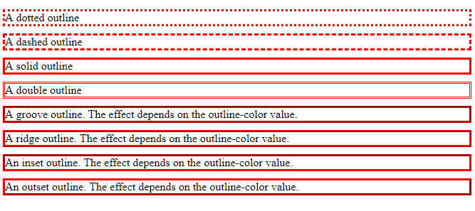

## **3.3 Outline Color**

**The outline-color property is used to set the color of the outline.**

**The color can be set by:**

* **name - specify a color name, like "red"**
* **RGB - specify a RGB value, like "rgb(255,0,0)"**
* **Hex - specify a hex value, like "#ff0000"**
* **invert - performs a color inversion (which ensures that the outline is visible, regardless of color background)**

**Example:**

**p.ex1 {**

**border: 1px solid black;**

**outline-style: solid;**

**outline-color: red;**

**}**

**p.ex2 {**

**border: 1px solid black;**

**outline-style: double;**

**outline-color: green;**

**}**

**p.ex3 {**

**border: 1px solid black;**

**outline-style: outset;**

**outline-color: yellow;**

**}**

**Output:**

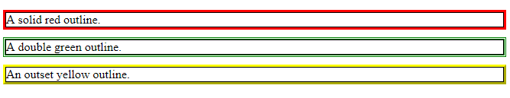

## **3.4 Outline Width**

**The outline-width property specifies the width of the outline, and can have one of the following values:**

* **thin (typically 1px)**
* **medium (typically 3px)**
* **thick (typically 5px)**
* **A specific size (in px, pt, cm, em, etc)**

**Example:**

**p.ex1 {**

**border: 1px solid black;**

**outline-style: solid;**

**outline-color: red;**

**outline-width: thin;**

**}**

**p.ex2 {**

**border: 1px solid black;**

**outline-style: solid;**

**outline-color: red;**

**outline-width: medium;**

**}**

**p.ex3 {**

**border: 1px solid black;**

**outline-style: solid;**

**outline-color: red;**

**outline-width: thick;**

**}**

**p.ex4 {**

**border: 1px solid black;**

**outline-style: solid;**

**outline-color: red;**

**outline-width: 4px;**

**}**

**Output:**

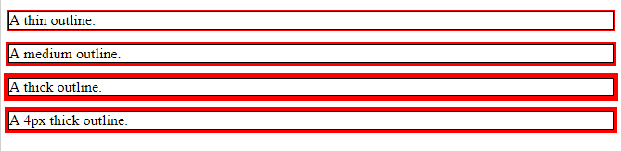

## **3.4 Outline Offset**

The outline-offset property adds space between an outline and the edge/border of an element. The space between an element and its outline is transparent.

Example:

p {

margin: 30px;

border: 1px solid black;

outline: 1px solid red;

outline-offset: 15px;

}

**Output:**



**4. Accessibility**

HTML with accessibility is more important. Provide the user a good way to navigate and interact with your site. Make your HTML code as semantic as possible, so that the code is easy to understand for visitors and screen readers.

## **4.1 Semantic HTML**

Semantic HTML means using correct HTML elements for their correct purpose as much as possible. Semantic elements are elements with a meaning; if you need a button, use the <button> element (and not a <div>).

**5. Aside Tag**

The <aside> tag defines some content aside from the content it is placed in.

The aside content should be related to the surrounding content.

**Example:**

**<p>My family and I visited The Epcot center this summer.</p>**

**<aside>**

**<h4>Epcot Center</h4>**

**<p>The Epcot Center is a theme park in Disney World, Florida.</p>**

**</aside>**

**Output:**

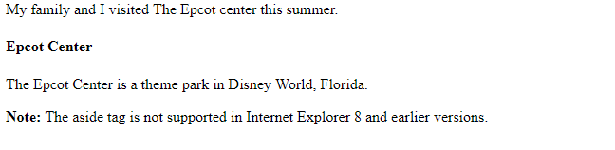

**6. Detail Tag**

**The <details> tag specifies additional details that the user can view or hide on demand.**

**The <details> tag can be used to create an interactive widget that the user can open and close. Any sort of content can be put inside the <details> tag.**

**The content of a <details> element should not be visible unless the open attribute is set.**

**Example:**

**<details>**

**<summary>Copyright 1999-2018.</summary>**

**<p> - by Refsnes Data. All Rights Reserved.</p>**

**<p>All content and graphics on this web site are the property of the company Refsnes Data.</p>**

**</details>**

**Output:**

**Before pressing the open attribute**

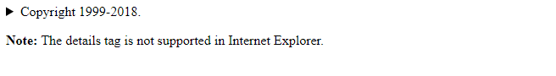

**After Setting the Open Tag**

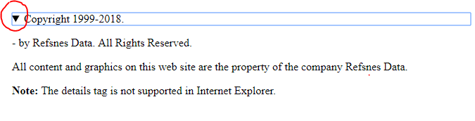

**7. Summary Tag**

The <summary> tag defines a visible heading for the [<details>](https://www.w3schools.com/tags/tag_details.asp) element. The heading can be clicked to view/hide the details.

***The Example is same as above details tag***

**8. Nav Tag**

The <nav> tag defines a set of navigation links.

Notice that NOT all links of a document should be inside a <nav> element. The <nav> element is intended only for major block of navigation links.

Browsers, such as screen readers for disabled users, can use this element to determine whether to omit the initial rendering of this content.

**Example:**

**<nav>**

**<a href="/html/">HTML</a> |**

**<a href="/css/">CSS</a> |**

**<a href="/js/">JavaScript</a> |**

**<a href="/jquery/">jQuery</a>**

**</nav>**

**OutPut:**

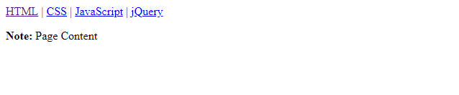

**9. Header Tag**

The <header> element represents a container for introductory content or a set of navigational links.

A <header> element typically contains:

* one or more heading elements (<h1> - <h6>)
* logo or icon
* authorship information

You can have several <header> elements in one document.

***Note****: A <header> tag cannot be placed within a <footer>, <address> or another <header> element.*

**Example:**

**<article>**

**<header>**

**<h1> h1 :Most important heading here</h1>**

**<h3> h3 :Less important heading here</h3>**

**<p>Some additional information here</p>**

**</header>**

**<p>Lorem Ipsum dolor set amet....</p>**

**</article>**

**Output:**

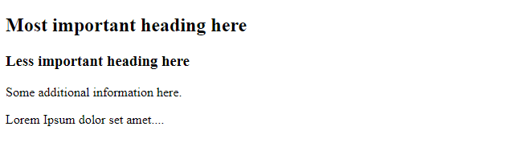

**10. Footer Tag**

The <footer> tag defines a footer for a document or section.

A <footer> element should contain information about its containing element.

A <footer> element typically contains:

* authorship information
* copyright information
* contact information
* sitemap
* back to top links
* related documents

You can have several <footer> elements in one document.

**Example:**

**<footer>**

**<p>Posted by: Hege Refsnes</p>**

**<p>Contact information: <a href="mailto:someone@example.com">**

**someone@example.com</a>.</p>**

**</footer>**

**Output:**

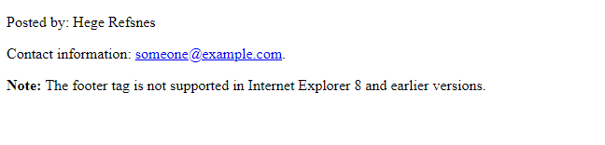

**References**

1. **https://www.w3schools.com/tags/tag_footer.asphttps://www.w3schools.com/tags/tag_footer.asp**